

Jayawant Shikshan Prasarak Mandal

LAB MANUAL

OF

DS & BDA Lab

T E (IT) 2019

COURSE

Information Technology

314457: DS & BDA Lab

Part A : Assignments based on the Hadoop
Practical Session Plan

Time ( min) | Content | Learning Aid / Methodology | Faculty Approach | Typical Student  Activity | Skill / Competency  Developed
05 | Relevance and significance of  experiment | Chalk & Talk , Presentation | Introduces, Facilitates,  Monitors | Listens, Participates,  Discusses | Knowledge, Communication,  intrapersonal
10 | Explanation of experiment | Chalk & Talk , Presentation | Introduces, Facilitates, Explains | Listens | Knowledge, Communication, intrapersonal,  Application
90 | Designing & Coding | demonstration | Explains, Monitors | Participates, Discusses | comprehension,  Hands on experiment
10 | Testing | Evaluation | Explains, Monitors | Participates, Discusses | Knowledge, Communication, Intrapersonal,  Application
05 | Output and conclusions | Demonstration Presentation | Lists, Facilitates | Listens, Participates, Discusses | Knowledge, Communication,  intrapersonal, Comprehension

Assignment No.1

Title: To perform Single node/Multiple node Hadoop Installation.

Objective: To study,
1. Configure Hadoop on open source software

ELO1: Able to install Hadoop on Single Node Cluster
-------------------------------------------------------------------------------------------------------------------

Theory:
Hadoop
Hadoop is an open sourcesoftware framework written in Java for distributed storage and distributed processing of very large data sets on computer clusters built from commodity hardware. All the modules in Hadoop are designed with a fundamental assumption that hardware failures (of individual machines or racks of machines) are common and thus should be automatically handled in software by the framework.

Traditional Approach

In this approach, an enterprise will have a computer to store and process big data. Here data will be stored in an RDBMS like Oracle Database, MS SQL Server or DB2 and sophisticated software can be written to interact with the database, process the required data and present it to the users for analysis purpose.
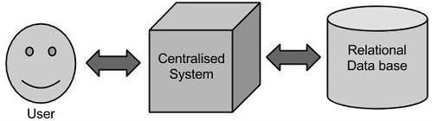

Limitation

This approach works well where we have less volume of data that can be accommodated by standard database servers, or up to the limit of the processor which is processing the data. But when it comes to dealing with huge amounts of data, it is really a tedious task to process such data through a traditional database server.

Google’s Solution

Google solved this problem using an algorithm called MapReduce. This algorithm divides the task into small parts and assigns those parts to many computers connected over the network, and collects the results to form the final result dataset.

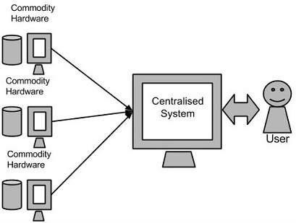

Above diagram shows various commodity hardware‟s which could be single CPU machines or servers with higher capacity.

Hadoop

Doug Cutting, Mike Cafarella and team took the solution provided by Google and started an Open Source Project called HADOOP in 2005 and Doug named it after his son's toy elephant. Now Apache Hadoop is a registered trademark of the Apache Software Foundation.

Hadoop runs applications using the MapReduce algorithm, where the data is processed in parallel on different CPU nodes. In short, Hadoop framework is capable enough to develop applications capable of running on clusters of computers and they could perform complete statistical analysis for huge amounts of data.
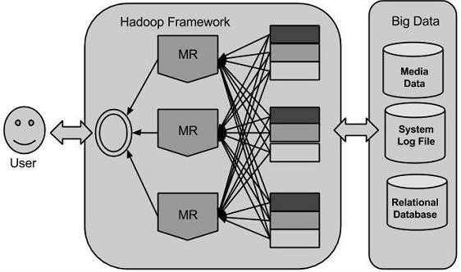

Hadoop Architecture

Hadoop framework includes following four modules:

Hadoop Common: These are Java libraries and utilities required by other Hadoop modules. These libraries providesfilesystem and OS level abstractions and contains the necessary Java files and scripts required to start Hadoop.

Hadoop YARN: This is a framework for job scheduling and cluster resource management.

Hadoop Distributed File System (HDFS™): A distributed file system that provides high- throughput access to application data.

HadoopMapReduce: This is YARN-based system for parallel processing of large data sets.

MapReduce

HadoopMapReduce is a software framework for easily writing applications which process big amounts of data in-parallel on large clusters (thousands of nodes) of commodity hardware in a reliable, fault-tolerant manner.

The term MapReduce actually refers to the following two different tasks that Hadoop programs perform:

- The Map Task: This is the first task, which takes input data and converts it into a set of data, where individual elements are broken down into tuples (key/value pairs).
- The Reduce Task: This task takes the output from a map task as input and combines those data tuples into a smaller set of tuples. The reduce task is always performed after the map task.

Typically both the input and the output are stored in a file-system. The framework takes care of scheduling tasks, monitoring them and re-executes the failed tasks.

The MapReduce framework consists of a single master JobTracker and one slave TaskTracker per cluster-node. The master is responsible for resource management, tracking resource consumption/availability and scheduling the jobs component tasks on the slaves, monitoring them and re-executing the failed tasks. The slaves TaskTracker execute the tasks as directed by the master and provide task-status information to the master periodically.

The JobTracker is a single point of failure for the HadoopMapReduce service which means if JobTracker goes down, all running jobs are halted.

Hadoop Distributed File System

Hadoop can work directly with any mountable distributed file system such as Local FS, HFTP FS, S3 FS, and others, but the most common file system used by Hadoop is the Hadoop Distributed File System (HDFS).

The Hadoop Distributed File System (HDFS) is based on the Google File System (GFS) and provides a distributed file system that is designed to run on large clusters (thousands of computers) of small computer machines in a reliable, fault-tolerant manner.

HDFS uses a master/slave architecture where master consists of a singleNameNode that manages the file system metadata and one or more slave DataNodes that store the actual data.

How to Install Hadoop on Ubuntu 18.04 or 20.04

- Install OpenJDK on Ubuntu.

- Set Up a Non-Root User for Hadoop Environment. Install OpenSSH on Ubuntu. ...
- Download and Install Hadoop on Ubuntu.
- Single Node Hadoop Deployment (Pseudo-Distributed Mode) ...
- Format HDFS NameNode.
- Start Hadoop Cluster.
- Access Hadoop UI from Browser.

How Does Hadoop Work? Stage 1
A user/application can submit a job to the Hadoop (a hadoop job client) for required process by specifying the following items:
- The location of the input and output files in the distributed file system.
- The java classes in the form of jar file containing the implementation of map and reduce functions.
- The job configuration by setting different parameters specific to the job.

Stage 2
The Hadoop job client then submits the job (jar/executable etc) and configuration to the JobTracker which then assumes the responsibility of distributing the software/configuration to the slaves, scheduling tasks and monitoring them, providing status and diagnostic information to the job-client. Stage 3
The TaskTrackers on different nodes execute the task as per MapReduce implementation and output of the reduce function is stored into the output files on the file system.

Advantages of Hadoop

- Hadoop framework allows the user to quickly write and test distributed systems. It is efficient, and it automatic distributes the data and work across the machines and in turn, utilizes the underlying parallelism of the CPU cores.
- Hadoop does not rely on hardware to provide fault-tolerance and high availability (FTHA), rather Hadoop library itself has been designed to detect and handle failures at the application layer.

Single Node:
Steps for Compilation & Execution
- sudo apt-get update
- sudo apt-get install openjdk-8-jre-headless
- sudo apt-get install openjdk-8-jdk
- sudo apt-get install ssh
- sudo apt-get install rsync
- # Download hadoop from : http://www.eu.apache.org/dist/hadoop/common/stable/hadoop- 2.7.1.tar.gz
- # copy and extract hadoop-2.7.1.tar.gz in home folder
- # rename the name of the extracted folder from hadoop-2.7.1 to hadoop
- readlink -f /usr/bin/javac
- gedit ~/hadoop/etc/hadoop/hadoop-env.sh
- # add following line in it

# for 32 bit ubuntu
- export JAVA_HOME=/usr/lib/jvm/java-8-openjdk-i386

# for 64 bit ubuntu
- export JAVA_HOME=/usr/lib/jvm/java-8-openjdk-amd64
- # save and exit the file
- # to display the usage documentation for the hadoop script try next command
- ~/hadoop/bin/hadoop

# Pseudo-Distributed mode
- # get your user name
- whoami
- # remember your user name, we'll use it in the next step
- gedit ~/hadoop/etc/hadoop/core-site.xml
<configuration>
<property>
<name>fs.defaultFS</name>
<value>hdfs://localhost:1234</value>
</property>
</configuration>

- gedit ~/hadoop/etc/hadoop/hdfs-site.xml
<configuration>
<property>
<name>dfs.replication</name>
<value>1</value>
</property>
<property>
<name>dfs.name.dir</name>
<value>file:///home/your_user_name/hadoop/name_dir</value>
</property>
<property>
<name>dfs.data.dir</name>
<value>file:///home/your_user_name/hadoop/data_dir</value>
</property>
</configuration>

#Setup passphraseless/passwordlessssh
- ssh-keygen -t dsa -P '' -f ~/.ssh/id_dsa
- cat ~/.ssh/id_dsa.pub >> ~/.ssh/authorized_keys
- export HADOOP\_PREFIX=/home/your_user_name/hadoop
- sshlocalhost
# typeexit in the terminal to close the ssh connection (very important)

Exit
# The following instructions are to run a MapReduce job locally.

Format the filesystem:( Do it only once )
~/hadoop/bin/hdfsnamenode -format

Start NameNode daemon and DataNode daemon:
~/hadoop/sbin/start-dfs.sh

Browse the web interface for the NameNode; by default it is available at:
http://localhost:50070/

Make the HDFS directories required to execute MapReduce jobs:
~/hadoop/bin/hdfsdfs -mkdir /user
~/hadoop/bin/hdfsdfs -mkdir /user/your_user_name

Copy the sample files (from ~/hadoop/etc/hadoop) into the distributed filesystem folder(input)
~/hadoop/bin/hdfsdfs -put ~/hadoop/etc/hadoop input

Run the example map-reduce job
~/hadoop/bin/hadoop jar ~/hadoop/share/hadoop/mapreduce/hadoop-mapreduce- examples-2.7.1.jar grep input output 'us[a-z.]+'

View the output files on the distributed filesystem
~/hadoop/bin/hdfsdfs -cat output/*

Copy the output files from the distributed filesystem to the local filesystem and examine them:
~/hadoop/bin/hdfsdfs -get output output

remove local output folder
rm -r output

remove distributed folders (input & output)
~/hadoop/bin/hdfsdfs -rm -r input output

When you’re done, stop the daemons with
~/hadoop/sbin/stop-dfs.sh

Flow Chart
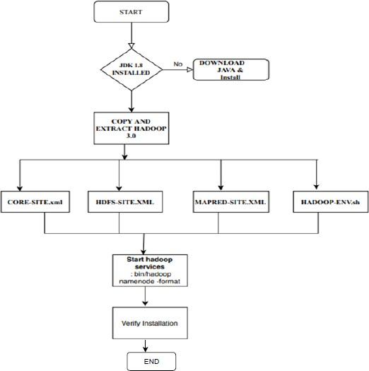

Reference :
- https://www.edureka.co/blog/install-hadoop-single-node-hadoop-cluster
- https://hadoop.apache.org/docs/r2.7.6/hadoop-project-dist/hadoop- common/SingleCluster.html

Software Requirement:
  - Ubuntu 18 / 18 2.Hadoop2.7.1

Conclusion: In this way the Hadoop was installed & configured on Ubuntu for BigData.

Questions:
Q1) what are the various daemons in Hadoop and their role in Hadoop Cluster? Q2) what does JPS command do?
Q3) what is difference between RDBMS vs.Hadoop Q4) what is YARN and explain its components?
Q5) Explain HDFS and its components?

EXPERIMENT NO.2
Title:

Design a distributed application using Map Reduce(Using Java) which processes a log file of a system. List out the users who have logged for maximum period on the system. Use simple log file from the Internet and process it using a pseudo distribution mode on Hadoop platform.

Objectives: To learn the concept of Mapper and Reducer and implement it for log file processing

Aim: To implement a MapReduce program that will process a log file of a system.

Theory
-------------------------------------------------------------------------------------------------------------------

Introduction
MapReduce is a framework using which we can write applications to process huge amounts of data, in parallel, on large clusters of commodity hardware in a reliable manner.MapReduce is a processing technique and a program model for distributed computing based on java.
The MapReduce algorithm contains two important tasks, namely Map and Reduce.Map takes a set of data and converts it into another set of data, where individual elements are broken down into tuples (key/value pairs).
Secondly, reduce task, which takes the output from a map as an input and combines those data tuples into a smaller set of tuples. As the sequence of the name MapReduce implies, the reduce task is always performed after the map job.
Under the MapReduce model, the data processing primitives are called mappers and reducers.
once we writean application in the MapReduce form, scaling the application to run over hundreds, thousands, or even tens of thousands of machines in a cluster is merely a configuration change

Algorithm
- MapReduce program executes in three stages, namely map stage, shuffle stage, and reduce stage.
  - Input : file or directory
  - Output : Sorted file<key, value>

Mapstage :
  - The map or mapper‟s job is to process the input data.
  - Generally the input data is in the form of file or directory and is stored in the Hadoop file system (HDFS).
  - The input file is passed to the mapper function line by line.
  - The mapper processes the data and creates several small chunks of data.

Shuffle stage:
  - This phase consumes the output of mapping phase.
  - Its task is to consolidate the relevant records from Mapping phase output

Reduce stage :
  - This stage is the combination of the Shuffle stage and the Reduce stage.
  - The Reducer‟s job is to process the data that comes from the mapper.
  - After processing, it produces a new set of output, which will be stored in the HDFS.

Inserting Data into HDFS:

•The MapReduce framework operates on <key, value>pairs, that is, the framework views the input to the job as a set of <key, value> pairs and produces a set of <key, value> pairs as the output of the job, conceivably of different types.
•The key and the value classes should be in serialized manner by the framework and hence, need to implement the Writable interface. Additionally, the key classes have to implement the Writable- Comparable interface to facilitate sorting by the framework.
- Input and Output types of a MapReduce job: (Input) <k1, v1> -> map -><k2, v2>-> reduce -

><k3, v3> (Output).

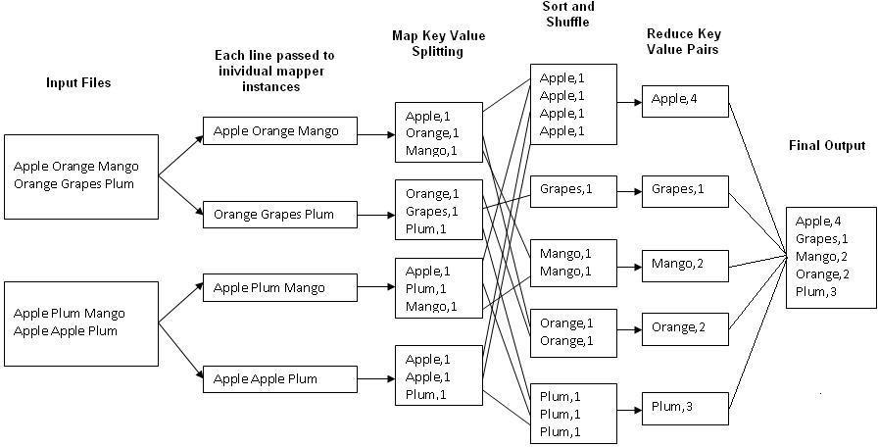

Fig.2.1 : An Example Program to Understand working of MapReduce Program.

Flow chart

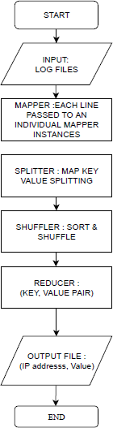
Program Code

#Mapper Class
packageSalesCountry; importjava.io.IOException;
importorg.apache.hadoop.io.IntWritable; importorg.apache.hadoop.io.LongWritable; importorg.apache.hadoop.io.Text; importorg.apache.hadoop.mapred.*;

public class SalesMapper extends MapReduceBase implements Mapper<LongWritable, Text, Text, IntWritable> {
private final static IntWritable one = new IntWritable(1);

public void map(LongWritable key, Text value, OutputCollector<Text, IntWritable> output, Reporter reporter) throws IOException {

String valueString = value.toString();
String[] SingleCountryData = valueString.split("-"); output.collect(new Text(SingleCountryData[0]), one);
}
}

#Reducer Class
packageSalesCountry;

importjava.io.IOException; importjava.util.*;

importorg.apache.hadoop.io.IntWritable; importorg.apache.hadoop.io.Text; importorg.apache.hadoop.mapred.*;

public class SalesCountryReducer extends MapReduceBase implements Reducer<Text, IntWritable, Text, IntWritable> {

public void reduce(Text t_key, Iterator<IntWritable> values, OutputCollector<Text,IntWritable> output, Reporter reporter) throws IOException {
Text key = t_key; intfrequencyForCountry = 0; while (values.hasNext()) {
// replace type of value with the actual type of our value IntWritable value = (IntWritable) values.next(); frequencyForCountry += value.get();

}
output.collect(key, new IntWritable(frequencyForCountry));
}
}

#Driver Class
packageSalesCountry;

importorg.apache.hadoop.fs.Path; import org.apache.hadoop.io.*; importorg.apache.hadoop.mapred.*;

public class SalesCountryDriver {
public static void main(String[] args) { JobClientmy_client = new JobClient();

// Create a configuration object for the job
JobConfjob_conf = new JobConf(SalesCountryDriver.class);

// Set a name of the Job
job_conf.setJobName("SalePerCountry");

// Specify data type of output key and value job_conf.setOutputKeyClass(Text.class); job_conf.setOutputValueClass(IntWritable.class);

// Specify names of Mapper and Reducer Class job_conf.setMapperClass(SalesCountry.SalesMapper.class); job_conf.setReducerClass(SalesCountry.SalesCountryReducer.class);

// Specify formats of the data type of Input and output

job_conf.setInputFormat(TextInputFormat.class); job_conf.setOutputFormat(TextOutputFormat.class);

// Set input and output directories using command line arguments,
//arg[0] = name of input directory on HDFS, and arg[1] = name of output directory to be created to store the output file.

FileInputFormat.setInputPaths(job_conf, new Path(args[0])); FileOutputFormat.setOutputPath(job_conf, new Path(args[1]));

my_client.setConf(job_conf); try {

// Run the job
JobClient.runJob(job_conf);
} catch (Exception e) {
e.printStackTrace();
}
}
}

Steps for Compilation & Execution of Program:
#sudomkdiranalyzelogs ls
#sudochmod -R 777 analyzelogs/ cd
ls cd .. pwd ls cd pwd
#sudochown -R hduseranalyzelogs/ cd
ls
#cd analyzelogs/ ls
cd ..

Copy the Files (Mapper.java,Reduce.java,Driver.java to Analyzelogs Folder)
#sudocp /home/mde/Desktop/count_logged_users/* -/analyzelogs/

Start HADOOP #start-dfs.sh #start-yarn.sh #jps
cd cdanalyzelogs ls
pwd

ls #ls -ltr #ls -al
#sudochmod +r *.* pwd

#export CLASSPATH="$HADOOP_HOME/share/hadoop/mapreduce/hadoop-mapreduce- client-core-2.9.0.jar:$HADOOP_HOME/share/hadoop/mapreduce/hadoop-mapreduce-client- common-2.9.0.jar:$HADOOP_HOME/share/hadoop/common/hadoop-common- 2.9.0.jar:~/analyzelogs/SalesCountry/*:$HADOOP_HOME/lib/*"

Compile Java Files
# javac -d . SalesMapper.java SalesCountryReducer.java SalesCountryDriver.java ls
#cd SalesCountry/ ls
cd ..
#sudogedit Manifest.txt
#jar -cfm analyzelogs.jar Manifest.txt SalesCountry/*.class ls
cd jps
#cd analyzelogs/

Create Directory on Hadoop

#sudomkdir ~/input2000 ls
pwd
#sudocp access_log_short.csv ~/input2000/
# $HADOOP_HOME/bin/hdfsdfs -put ~/input2000 /
# $HADOOP_HOME/bin/hadoop jar analyzelogs.jar /input2000 /output2000 # $HADOOP_HOME/bin/hdfsdfs -cat /output2000/part-00000

# stop-all.sh
# jps

Output:

hduser@com17-Veriton-M200-A780:~/analyzelog$ $HADOOP_HOME/bin/hdfsdfs -cat
/output2000/part-00000
18/01/08 10:13:25 WARN util.NativeCodeLoader: Unable to load native-hadoop library for your platform... using builtin-java classes where applicable
10.1.1.236 7 10.1.181.142 14 10.1.232.31 5 10.10.55.142 14 10.102.101.66 1
10.103.184.104 1
10.103.190.81 53
10.103.63.29 1

10.104.73.51 1
10.105.160.183 1
10.108.91.151 1
10.109.21.76 | 1
10.11.131.40 | 1
10.111.71.20 | 8
10.112.227.184 |  | 6
10.114.74.30 1
10.115.118.78 |  | 1
10.117.224.230 |  | 1
10.117.76.22 12
10.118.19.97 1
10.118.250.30 |  | 7
10.119.117.132 |  | 23
10.119.33.245 |  | 1
10.119.74.120 |  | 1
10.12.113.198 |  | 2
10.12.219.30 1
10.120.165.113 |  | 1
10.120.207.127 |  | 4
10.123.124.47 |  | 1
10.123.35.235 |  | 1
10.124.148.99 |  | 1
10.124.155.234 |  | 1
10.126.161.13 |  | 7
10.127.162.239 |  | 1
10.128.11.75 10
10.13.42.232 1
10.130.195.163 |  | 8
10.130.70.80 1
10.131.163.73 |  | 1
10.131.209.116 |  | 5
10.132.19.125 |  | 2
10.133.222.184 |  | 12
10.134.110.196 |  | 13
10.134.242.87 |  | 1
10.136.84.60 5
10.14.2.86 8
10.14.4.151 2
hduser@com17-Veriton-M200-A780:~/analyzelog$

Conclusion: Thus we have learnt how to design a distributed application using MapReduce and process a log file of a system.

EXPERIMENT NO. 3

Part A: Assignments based on the Hadoop HBase via Hive Title:
Write an application using HiveQL for flight information system which will include a. Creating, Dropping, and altering Database tables. b. Creating an external Hive table. c. Load table with data, insert new values and field in the table, Join tables with Hive d. Create index on Flight Information Table e. Find the average departure delay per day in 2008.
Objectives: 1) To describe the basics of Hive
2)Explain the components of the Hadoop ecosystem
Aim: To execute a Hive that will perform CRUD operation on Flight Table

Theory
--------------------------------------------------------------------------------------------------------------------

Hive – Introduction
Hive is defined as a data warehouse system for Hadoop that facilitates ad-hoc queries and the analysis of large datasets stored in Hadoop.
Following are the facts related to Hive:

  - It provides a SQL-like language called HiveQL(HQL). Due to its SQL-like interface, Hive is a popular choice for Hadoop analytics.
  - It provides massive scale-out and faults tolerance capabilities for data storage and processing of commodity hardware.
  - Relying on MapReduce for execution, Hive is batch-oriented and has high latency for query execution

Hive – Characteristics
  - Hive is a system for managing and querying unstructured data into a structured format.
  - It uses the concept of MapReduce for the execution of its scripts and the Hadoop Distributed File System or HDFS for storage and retrieval of data.

Following are the key principles underlying Hive.
  - Hive commands are similar to that of SQL. SQL is a data warehousing tool that is similar to Hive.
  - Hive contains extensive, pluggable MapReduce scripts in the language of your choice. These scripts include rich, user-defined data types and user-defined functions.
  - Hive has an extensible framework to support different files and data formats.
  - Performance is better in Hive since Hive engine uses the best-inbuilt script to reduce the execution time, thus enabling high output in less time.

Architecture of Hive
The following component diagram depicts the architecture of Hive:

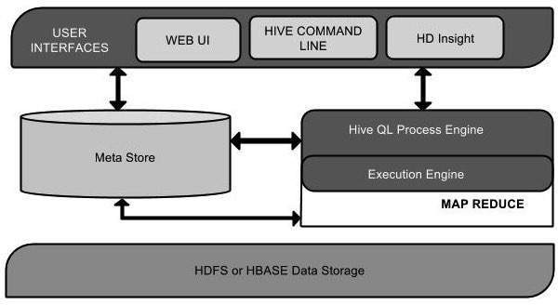

Unit Name | Operation
User Interface | Hive is a data warehouse infrastructure software that can create interaction between user and HDFS. The user interfaces that  Hive supports are Hive Web UI, Hive command line, and Hive HD Insight
Meta Store | Hive chooses respective database servers to store the schema or Metadata of tables, databases, columns in a table, their data  types, and HDFS mapping.
HiveQL Process Engine | HiveQL is similar to SQL for querying on schema info on the Metastore. Instead of writing MapReduce program in Java, we  can write a query for MapReduce job and process it.
Execution Engine | The conjunction part of HiveQL process Engine and MapReduce is Hive Execution Engine. Execution engine processes the query and generates results as same as  MapReduce results.
HDFS or HBASE | Hadoop distributed file system or HBASE are the data storage  techniques to store data into file system.

Listing 13-1: Installing Apache Hadoop and Hive
$ mkdirhadoop; cp hadoop-1.2.1.tar.gz hadoop; cd hadoop
$ gunzip hadoop-1.2.1.tar.gz
$ tar xvf *.tar
$ mkdir hive; cp hive-0.11.0.tar.gz hive; cd hive
$ gunzip hive-0.11.0.tar.gz
$ tar xvf *.tar

Listing 13-2: Setting Up Apache Hive Environment Variables in .bashrc
export HADOOP_HOME=/home/user/Hive/hadoop/hadoop-1.2.1 export JAVA_HOME=/opt/jdk export HIVE_HOME=/home/user/Hive/hive-0.11.0 export PATH=$HADOOP_HOME/bin:$HIVE_HOME/bin:
$JAVA_HOME/bin:$PATH

Listing 13-3: Setting Up the hive-site.xml File
$ cd $HIVE_HOME/conf
$ cp hive-default.xml.templateto hive-site.xml

<?xml version="1.0"?>
<?xml-stylesheet type="text/xsl" href="configuration.xsl"?>
<configuration>
<!-- Hive Execution Parameters -->
<property>
<name>hive.metastore.warehouse.dir</name>

<value>/home/biadmin/Hive/warehouse</value>
<description>location of default database for the warehouse</description>
</property>
</configuration>

Working with Hive Data Types
Listing 13-7 goes to the trouble of creating a table that uses all Hive-supported data types and the amount of memory required.

Commands for Hive

Create Database Statement In Hive

hive> CREATE DATABASE userdb;

Create Table Statement

hive> CREATE TABLE IF NOT EXISTS employee ( eidint, name String, salary String, destination String)COMMENT „Employee details‟ROW
FORMAT DELIMITED FIELDS TERMINATED BY „\t‟LINES TERMINATED BY „\n‟STORED AS TEXTFILE;

Alter Table Statement
hive> ALTER TABLE employee RENAME TO emp;

Drop Table Statement
hive>DROP TABLE IF EXISTS employee;

Creating, Dropping, and altering Database tables
hbase(main):001:0> create 'flight','finfo','fsch'

SLF4J: Class path contains multiple SLF4J bindings.

SLF4J: Found binding in [jar:file:/home/suruchi/hbase/lib/slf4j- log4j12-1.6.4.jar!/org/slf4j/impl/StaticLoggerBinder.class]

SLF4J: Found binding in [jar:file:/usr/local/hadoop-1.2.1/lib/slf4j- log4j12-1.4.3.jar!/org/slf4j/impl/StaticLoggerBinder.class]

SLF4J: See http://www.slf4j.org/codes.html#multiple_bindings for an explanation.

0 row(s) in 1.6440 seconds
=>Hbase::Table – flight

hbase(main):014:0> disable'tb1'

0 row(s) in 1.4940 seconds

hbase(main):015:0> drop 'tb1'

0 row(s) in 0.2540 seconds

Load table with data, insert new values and field in the table, Join tables with Hive hbase(main):002:0> put 'flight',1,'finfo:dest','mumbai'
0 row(s) in 0.1400 seconds

hbase(main):003:0> put 'flight',1,'finfo:source','pune'

0 row(s) in 0.0070 seconds

hbase(main):004:0> put 'flight',1,'fsch:at','10.25am'

0 row(s) in 0.0120 seconds

hbase(main):005:0> put 'flight',1,'fsch:dt','11.25am'

- row(s) in 0.0100 seconds

hbase(main):006:0> scan 'flight'

ROW COLUMN+CELL

- column=finfo:dest, timestamp=1554629442188, value=mumbai

1 column=finfo:source, timestamp=1554629455512, value=pune

1 column=fsch:at, timestamp=1554629478320, value=10.25am
1 column=fsch:dt, timestamp=1554629491414, value=11.25am 1 row(s) in 0.0450 seconds

hbase(main):007:0> alter 'flight',Name='revenue'

Updating all regions with the new schema... 0/1 regions updated.
1/1 regions updated.

Done.

0 row(s) in 2.3720 seconds

hbase(main):008:0> put 'flight',1,'revenue',10000

0 row(s) in 0.0110 seconds

hbase(main):016:0> get 'flight',1

COLUMN CELL

finfo:dest timestamp=1554629442188, value=mumbai finfo:source timestamp=1554629455512, value=pune fsch:at timestamp=1554629478320, value=10.25am fsch:dt timestamp=1554629491414, value=11.25am revenue: timestamp=1554629582539, value=10000
5 row(s) in 0.0310 seconds

Create index on Flight information Table
hive>CREATE INDEX ine ON TABLE FLIGHT(source) AS 'org.apache.hadoop.hive.ql.index.compact.CompactIndexHandler' WITH DEFERRED REBUILD;

OK
Time taken: 1.841 seconds hive>SHOW INDEX ON FLIGHT;

OK

Time taken: 0.126 seconds, Fetched: 1 row(s)

Find the average departure delay per day in 2008.
hive>select avg(delay) from flight where year = 2008;

Conclusion: Thus we have learnt to integrate Hive with Hbase

Part-B EXPERIMENT NO.4

- Perform the following operations using Python on the Facebook metrics data sets
  - Create data subsets
  - Merge Data
  - Sort Data
  - Transposing Data
  - Shape and reshape Data

Objectives:
    - To understand and apply the Analytical concept of Big data using R/Python.
    - To study detailed concept R.
Aim:To perform basic analytical operation on given dataset

Theory:
Python is an object-oriented programming language created by Guido Rossum in 1989. It is ideally designed for rapid prototyping of complex applications. It has interfaces to many OS system calls and libraries and is extensible to C or C++. Many large companies use the Python programming language, including NASA, Google, YouTube, BitTorrent, etc.
Features of Python is as it is a dynamic, high level, free open source and interpreted programming language. It supports object-oriented programming as well as procedural oriented programming.
- Easy to code:
Python is a high-level programming language. Python is very easy to learn the language as compared to other languages like C, C#, Javascript, Java, etc. It is very easy to code in python language and anybody can learn python basics in a few hours or days. It is also a developer- friendly language.
- Free and Open Source:
Python language is freely available at the official website and you can download it from the given download link

# Group B:Assignment based on Data analytic using python
import pandas as pd import numpy as np
df=pd.read_excel("dataset_Facebook_1_xlsx")

#Perform following operation using python on facebook matrics data sets

df.head()

df.info() df.isnull()
df.dropna(how='any',axis=0)

# Create data subsets

df1=df.loc[1:245,['Category','Lifetime Post Total Reach','Type','Total Interactions']] df2=df.loc[245:500,['Post Month','Post Weekday','Post Hour','Lifetime Post Consumers']] df1
df2

# Mearge 2 dataset/subsets df_row = pd.concat([df1, df2]) df_row

#shape and reshape data

df.shape df.melt()
# Transposing Data df.transpose() df1.transpose() df2.transpose()
# Sorting data df.sort_values(by='Category') df.sort_index()

CONCLUSION:Thus we have learnt how to perform the different reshape operations using R.

Title:
Part-B EXPERIMENT NO. 5

Perform the following operations using Python on the Air quality and Heart Diseases data sets
1) Data cleaning 2) Data integration
3) Data transformation 4) Error correcting
- Data model building

Objectives:
  - To understand and apply the Analytical concept of Big data using Python. 2.To study detailed concept Python.

THEORY:

Data cleaning or data preparation is an essential part of statistical analysis. In fact,in practice it is
often more time-consuming than the statistical analysis itself
1) 1) Data cleaning

import pandas as pd import numpy as np
import matplotlib.pyplot as plt import random as rd

ds = pd.read_excel("AirQuality.xlsx") ds_heart = pd.read_csv("heart.csv") ds.head()
ds.info()

<class 'pandas.core.frame.DataFrame'> RangeIndex: 9357 entries, 0 to 9356 Data columns (total 15 columns): # Column Non-Null Count Dtype 0 Date 9357 non-null object
1 Time 9357 non-null object 2 CO(GT) 9357 non-null object 3 PT08.S1(CO) 9357 non-null int64 4 NMHC(GT) 9357 non-null int64

ds.isnull().sum() ds.dropna()

Data integration
ds1 = ds.loc[111:999, ['Date', 'Time', 'C6H6(GT)', 'RH']]
ds2 = ds.iloc[[1,3,5,2,4,22,43,54,67,7,8,9,50,10,11]]
ds_integration = pd.concat([ds1,ds2])
ds_integration

- Data transformation
ds_integration.transpose()

ds.drop(columns = "NOx(GT)") ds2.drop(1)
ds.melt()

ds_merged = pd.concat([ds,ds_heart]) ds_merged

Error correcting:
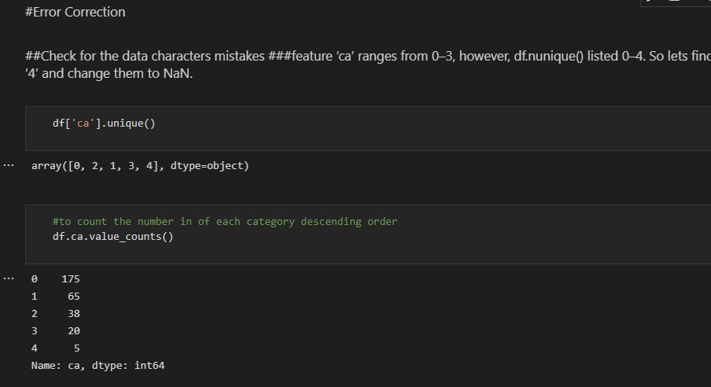

- Data model building

# Step1 : Divide the dataset into taining and Testing #step 2:design a model
Step 3:perform the accuracy measures

SOFTWARE REQUIREMENTS:
1. Ubuntu 14.04 / 14.10
  - GNU C Compiler
  - Hadoop
  - Java

CONCLUSION:Thus we have learnt how to Perform the different Data Cleaning and Data modeling operations using Python .

OBJECTIVE:
EXPERIMENT 6
TITLE: Integrate Python and Hadoop and perform the following operations on forest fire dataset
- To understand and apply the Analytical concept of Big data using Python.
- To study detailed concept Hadoop .

SOFTWARE REQUIREMENTS:
1. Ubuntu 14.04 / 14.10
- GNU C Compiler
- Hadoop
- Java

PROBLEM STATEMENT: Integrate Python and perform the following operations on forest fire dataset
- Data analysis using the Map Reduce in PyTHON
- Data mining in Hive

THEORY:
Write theory by your own for-

  - Text mining
  - PyHadoop
  - Hive
  - MapReduce

TITLE
EXPERIMENT 7
Visualize the data using Python libraries matplotlib, seaborn by plotting the graphs for assignment no. 2 and 3 ( Group B)

OBJECTIVE:
- To understand and apply the Analytical concept of Big data using Python.
- To study detailed concept Python.

SOFTWARE REQUIREMENTS:
1. Ubuntu 14.04 / 14.10
- GNU C Compiler
- Hadoop
- Java

PROBLEM STATEMENT: Visualize the data using Python libraries matplotlib, seaborn by plotting the graphs for assignment no. 2 and 3 ( Group B)

THEORY:
Data Visualisation in Python using Matplotlib and Seaborn

Data visualization is an easier way of presenting the data, however complex it is, to analyze trends and relationships amongst variables with the help of pictorial representation.
The following are the advantages of Data Visualization
- Easier representation of compels data
- Highlights good and bad performing areas
- Explores relationship between data points
- Identifies data patterns even for larger data points
While building visualization, it is always a good practice to keep some below mentioned points in mind
- Ensure appropriate usage of shapes, colors, and size while building visualization
- Plots/graphs using a co-ordinate system are more pronounced
- Knowledge of suitable plot with respect to the data types brings more clarity to the information
- Usage of labels, titles, legends and pointers passes seamless information the wider audience

Python Libraries
There are a lot of python libraries which could be used to build visualization like matplotlib, vispy, bokeh, seaborn, pygal, folium, plotly, cufflinks, and networkx. Of the
many, matplotlib and seaborn seems to be very widely used for basic to intermediate level of visualizations.

Matplotlib
It is an amazing visualization library in Python for 2D plots of arrays, It is a multi-platform data visualization library built on NumPy arrays and designed to work with the broader SciPy stack. It was introduced by John Hunter in the year 2002. Let‟s try to understand some of the benefits and features of matplotlib
- It‟s fast, efficient as it is based on numpy and also easier to build
- Has undergone a lot of improvements from the open source community since inception and hence a better library having advanced features as well
- Well maintained visualization output with high quality graphics draws a lot of users to it

- Basic as well as advanced charts could be very easily built
- From the users/developers point of view, since it has a large community support, resolving issues and debugging becomes much easier

Seaborn
Conceptualized and built originally at the Stanford University, this library sits on top of matplotlib. In a sense, it has some flavors of matplotlib while from the visualization point, its is much better than matplotlib and has added features as well. Below are its advantages
- Built-in themes aid better visualization
- Statistical functions aiding better data insights
- Better aesthetics and built-in plots
- Helpful documentation with effective examples

Nature of Visualization
Depending on the number of variables used for plotting the visualization and the type of variables, there could be different types of charts which we could use to understand the relationship. Based on the count of variables, we could have
- Univariate plot(involves only one variable)
- Bivariate plot(more than one variable in required)
A Univariate plot could be for a continuous variable to understand the spread and distribution of the variable while for a discrete variable it could tell us the count
Similarly, a Bivariate plot for continuous variable could display essential statistic like correlation, for a continuous versus discrete variable could lead us to very important conclusions like understanding data distribution across different levels of a categorical variable. A bivariate plot between two discrete variables could also be developed.

Box plot
A boxplot, also known as a box and whisker plot, the box and the whisker are clearly displayed in the below image. It is a very good visual representation when it comes to measuring the data distribution. Clearly plots the median values, outliers and the quartiles. Understanding data distribution is another important factor which leads to better model building. If data has outliers, box plot is a recommended way to identify them and take necessary actions.
Syntax: seaborn.boxplot(x=None, y=None, hue=None, data=None, order=None, hue_order=None, orient=None, color=None, palette=None, saturation=0.75, width=0.8, dodge=True, fliersize=5, linewidth=None, whis=1.5, ax=None, **kwargs)

Parameters:
x, y, hue: Inputs for plotting long-form data.
data: Dataset for plotting. If x and y are absent, this is interpreted as wide-form.
color: Color for all of the elements.
Returns: It returns the Axes object with the plot drawn onto it.
The box and whiskers chart shows how data is spread out. Five pieces of information are generally included in the chart
- The minimum is shown at the far left of the chart, at the end of the left „whisker‟
- First quartile, Q1, is the far left of the box (left whisker)
- is shown as a line in the center of the box The median
- Third quartile, Q3, shown at the far right of the box (right whisker)
- The maximum is at the far right of the box
As could be seen in the below representations and charts, a box plot could be plotted for one or more than one variable providing very good insights to our data.
Representation of box plot.

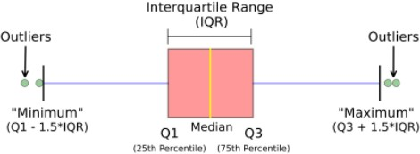
Box plot representing multi-variate categorical variables
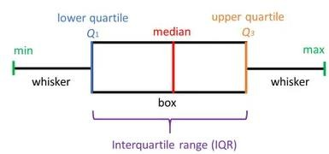
Box plot representing multi-variate categorical variables
- Python3

# import required modules import matplotlib as plt import seaborn as sns

# Box plot and violin plot for Outcome vs BloodPressure
_, axes = plt.subplots(1, 2, sharey=True, figsize=(10, 4))

# box plot illustration
sns.boxplot(x='Outcome', y='BloodPressure', data=diabetes, ax=axes[0])

# violin plot illustration
sns.violinplot(x='Outcome', y='BloodPressure', data=diabetes, ax=axes[1])

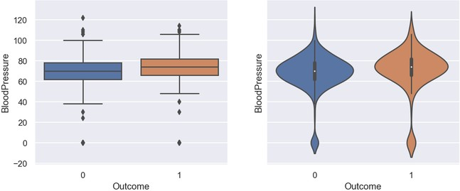
Output for Box Plot and Violin Plot
- Python3

# Box plot for all the numerical variables sns.set(rc={'figure.figsize': (16, 5)})

# multiple box plot illustration sns.boxplot(data=diabetes.select_dtypes(include='number'))
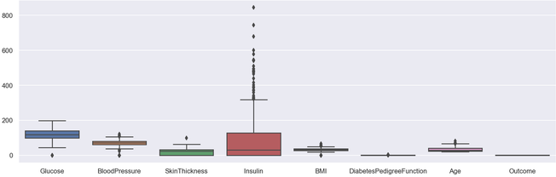
Output Multiple Box PLot

Scatter Plot
Scatter plots or scatter graphs is a bivariate plot having greater resemblance to line graphs in the way they are built. A line graph uses a line on an X-Y axis to plot a continuous function, while a scatter plot relies on dots to represent individual pieces of data. These plots are very useful to see if two variables are correlated. Scatter plot could be 2 dimensional or 3 dimensional.
Syntax: seaborn.scatterplot(x=None, y=None, hue=None, style=None, size=None, data=None, palette=None, hue_order=None, hue_norm=None, sizes=None, size_order=None, size_norm=None, markers=True, style_order=None, x_bins=None, y_bins=None, units=None, estimator=None, ci=95, n_boot=1000, alpha=’auto’, x_jitter=None, y_jitter=None, legend=’brief’, ax=None, **kwargs)

Parameters:
x, y: Input data variables that should be numeric.
data: Dataframe where each column is a variable and each row is an observation.
size: Grouping variable that will produce points with different sizes.
style: Grouping variable that will produce points with different markers. palette: Grouping variable that will produce points with different markers. markers: Object determining how to draw the markers for different levels. alpha: Proportional opacity of the points.
Returns: This method returns the Axes object with the plot drawn onto it.

Advantages of a scatter plot

- Displays correlation between variables
- Suitable for large data sets
- Easier to find data clusters
- Better representation of each data point

- Python3

# import module
import matplotlib.pyplot as plt

# scatter plot illustration plt.scatter(diabetes['DiabetesPedigreeFunction'], diabetes['BMI'])
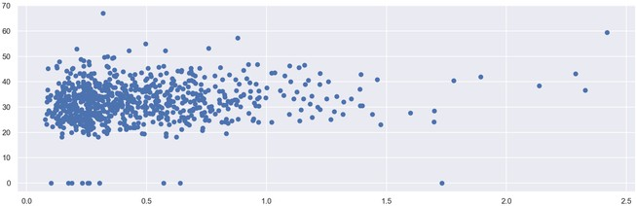
Output 2D Scattered Plot
- Python3

# import required modules
from mpl_toolkits.mplot3d import Axes3D

# assign axis values
x = [1, 2, 3, 4, 5, 6, 7, 8, 9, 10]
y = [5, 6, 2, 3, 13, 4, 1, 2, 4, 8]

z = [2, 3, 3, 3, 5, 7, 9, 11, 9, 10]

# adjust size of plot sns.set(rc={'figure.figsize': (8, 5)}) fig = plt.figure()
ax = fig.add_subplot(111, projection='3d') ax.scatter(x, y, z, c='r', marker='o')

# assign labels
ax.set_xlabel('X Label'), ax.set_ylabel('Y Label'), ax.set_zlabel('Z Label')

# display illustration plt.show()
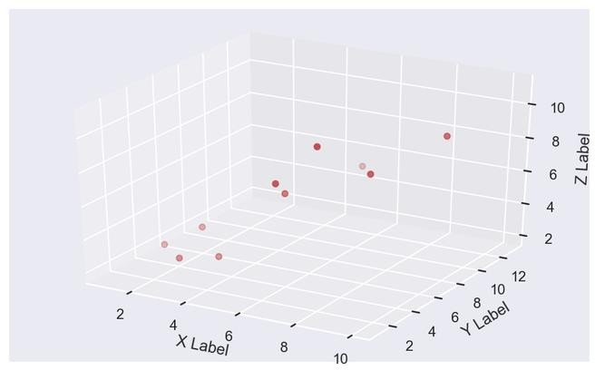
Output 3D Scattered Plot

Histogram
Histograms display counts of data and are hence similar to a bar chart. A histogram plot can also tell us how close a data distribution is to a normal curve. While working out statistical method, it is very important that we have a data which is normally or close to a normal distribution. However, histograms are univariate in nature and bar charts bivariate.
A bar graph charts actual counts against categories e.g. height of the bar indicates the number of items in that category whereas a histogram displays the same categorical variables in bins.
Bins are integral part while building a histogram they control the data points which are within a range. As a widely accepted choice we usually limit bin to a size of 5-20, however this is totally governed by the data points which is present.

- Python3

# illustrate histogram
features = ['BloodPressure', 'SkinThickness'] diabetes[features].hist(figsize=(10, 4))
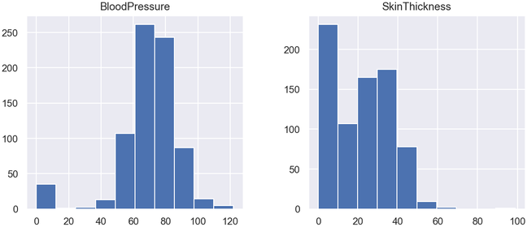
Output Histogram

Pie Chart
Pie chart is a univariate analysis and are typically used to show percentage or proportional data. The percentage distribution of each class in a variable is provided next to the corresponding slice of the pie. The python libraries which could be used to build a pie chart is matplotlib and seaborn.
Syntax: matplotlib.pyplot.pie(data, explode=None, labels=None, colors=None, autopct=None, shadow=False)

Parameters:
data represents the array of data values to be plotted, the fractional area of each slice is represented by data/sum(data). If sum(data)<1, then the data values returns the fractional area directly, thus resulting pie will have empty wedge of size 1-sum(data).
labels is a list of sequence of strings which sets the label of each wedge.
color attribute is used to provide color to the wedges.
autopct is a string used to label the wedge with their numerical value.
shadow is used to create shadow of wedge.
Below are the advantages of a pie chart
- Easier visual summarization of large data points
- Effect and size of different classes can be easily understood
- Percentage points are used to represent the classes in the data points
- Python3

# import required module import matplotlib.pyplot as plt

# Creating dataset

cars = ['AUDI', 'BMW', 'FORD', 'TESLA', 'JAGUAR', 'MERCEDES']
data = [23, 17, 35, 29, 12, 41]

# Creating plot
fig = plt.figure(figsize=(10, 7)) plt.pie(data, labels=cars)

# Show plot plt.show()

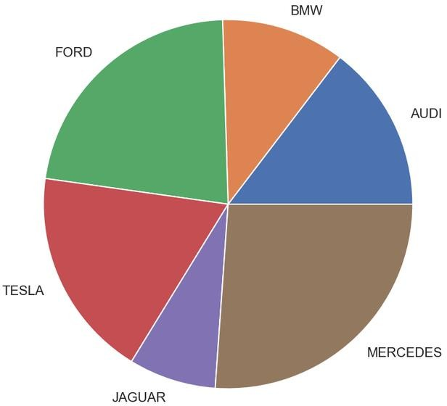

Output Pie Chart

- Python3

# Import required module import matplotlib.pyplot as plt import numpy as np

# Creating dataset
cars = ['AUDI', 'BMW', 'FORD', 'TESLA', 'JAGUAR', 'MERCEDES']
data = [23, 17, 35, 29, 12, 41]

# Creating explode data
explode = (0.1, 0.0, 0.2, 0.3, 0.0, 0.0)

# Creating color parameters
colors = ("orange", "cyan", "brown", "grey", "indigo", "beige")

# Wedge properties
wp = {'linewidth': 1, 'edgecolor': "green"}

# Creating autocpt arguments def func(pct, allvalues):
absolute = int(pct / 100.*np.sum(allvalues)) return "{:.1f}%\n({:d} g)".format(pct, absolute)

# Creating plot
fig, ax = plt.subplots(figsize=(10, 7))
wedges, texts, autotexts = ax.pie(data, autopct=lambda pct: func(pct, data), explode=explode, labels=cars,
shadow=True, colors=colors, startangle=90,
wedgeprops=wp,
textprops=dict(color="magenta"))

# Adding legend
ax.legend(wedges, cars, title="Cars", loc="center left", bbox_to_anchor=(1, 0, 0.5, 1))
plt.setp(autotexts, size=8, weight="bold") ax.set_title("Customizing pie chart")

# Show plot plt.show()

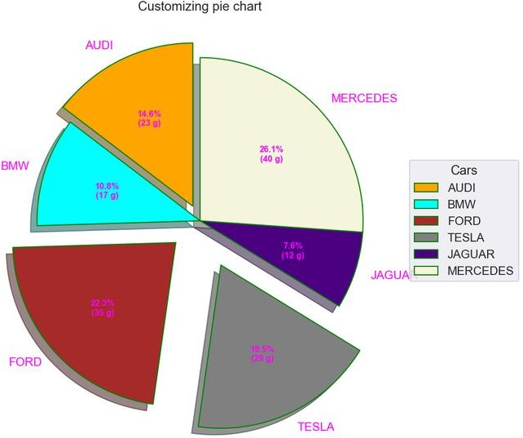
Output
CONCLUSION:Thus we have learnt Visualize the data using Python by plotting the graphs .

ASSIGNMENT-8
Aim:

Perform the following data visualization operations using Tableau on Adult and Iris datasets
- 1D (Linear) Data visualization

2D (Planar) Data Visualization
- 3D (Volumetric) Data Visualization

Temporal Data Visualization
- Multidimensional Data Visualization

Tree/ Hierarchical Data visualization
- Network Data visualization

-------------------------------------------------------------------------------------------------------------------
Introduction
Data visualization or data visualization is viewed by many disciplines as a modern equivalent of visual communication. It involves the creation and study of the visual representation of data, meaning "information that has been abstracted in some schematic form, including attributes or variables for the units of information".
Data visualization refers to the techniques used to communicate data or information by encoding it as visual objects (e.g., points, lines or bars) contained in graphics. The goal is to communicate information clearly and efficiently to users. It is one of the steps in data analysis or data science
1D/Linear
Examples:

  - lists of data items, organized by a single feature (e.g., alphabetical order) (not commonly visualized)
2D/Planar (especially geospatial)
Examples (geospatial):
  - choropleth
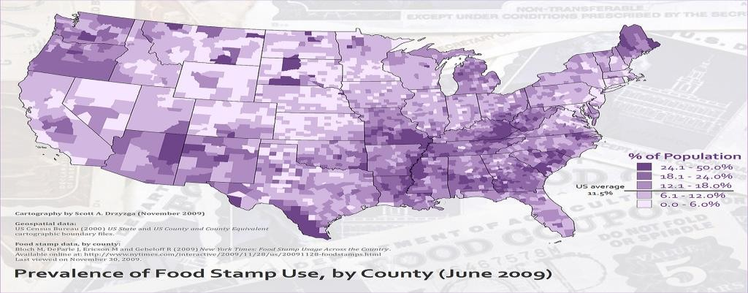
3D/Volumetric

3D/Volumetric
Broadly, examples of scientific visualization:

  - 3D computer models

In 3D computer graphics, 3D modeling (or three-dimensional modeling) is the process of developing a mathematical representation of any surface of an object (either inanimate or living) in three dimensions via specialized software. The product is called a 3D model. Someone who works with 3D models may be referred to as a 3D artist. It can be displayed as a two-dimensional image through a process called 3D rendering or used in a computer simulation of physical phenomena. The model can also be physically created using 3D printing devices.

  - surface and volume rendering

Rendering is the process of generating an image from a model, by means of computer programs. The model is a description of three-dimensional objects in a strictly defined language or data structure. It would contain geometry, viewpoint, texture, lighting, and shading information. The image is a digital image or raster graphics image. The term may be by analogy with an "artist's rendering" of a scene. 'Rendering' is also used to describe the process of calculating effects in a video editing file to produce final video output.

Volume rendering is a technique used to display a 2D projection of a 3D discretely sampled data set. A typical 3D data set is a group of 2D slice images acquired by a CT or MRI scanner. Usually these are acquired in a regular pattern (e.g., one slice every millimeter) and usually have a regular number of image pixels in a regular pattern. This is an example of a regular volumetric grid, with each volume element, or voxel represented by a single value that is obtained by sampling the immediate area surrounding the voxel.

  - computer simulations

Computer simulation is a computer program, or network of computers, that attempts to simulate an abstract model of a particular system. Computer simulations have become a useful part of mathematical modeling of many natural systems in physics, and computational physics, chemistry and biology; human systems in economics, psychology, and social science; and in the process of engineering and new technology, to gain insight into the operation of those systems, or to observe their behavior.^{[6]} The simultaneous visualization and simulation of a system is called visulation.
Temporal
Examples:
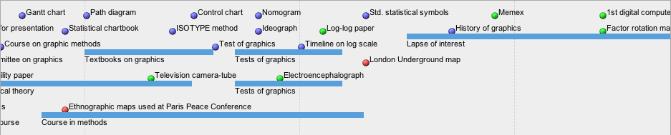
  - timeline

Tools: SIMILE Timeline, TimeFlow, Timeline JS, Excel

Image:
Friendly, M. & Denis, D. J. (2001). Milestones in the history of thematic cartography, statistical graphics, and data visualization.Web
document, http://www.datavis.ca/milestones/.Accessed: August 30, 2012.
  - time series
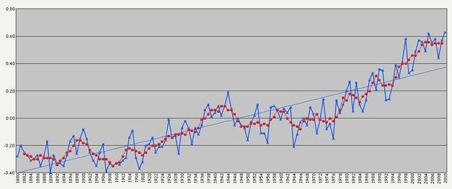
nD/Multidimensional

Examples (category proportions, counts):
  - histogram
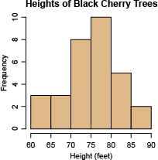

  - pie chart
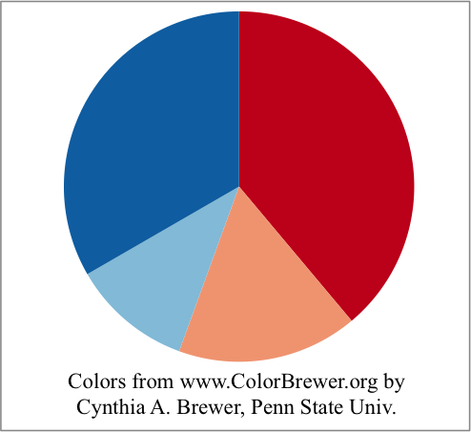

Tree/Hierarchical
Examples:
  - general tree visualization

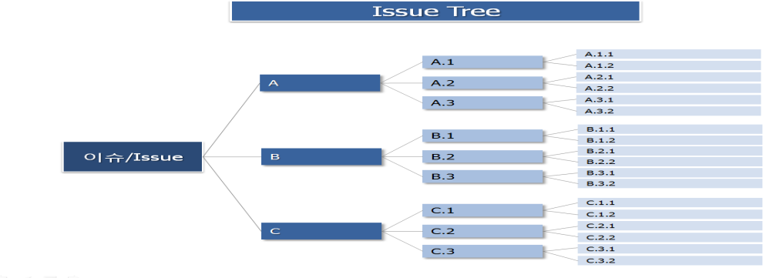

  - dendrogram
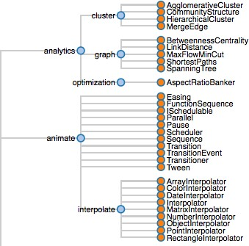

Network
Examples:

matrix

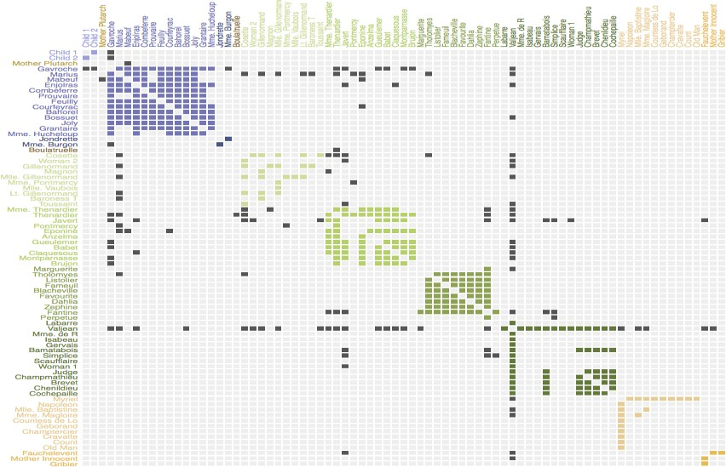

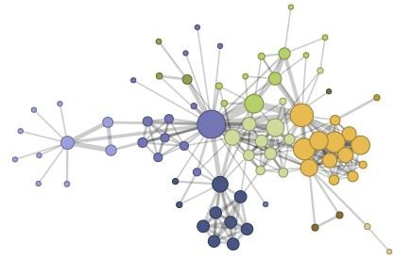
- node-link diagram (link-based layout algorithm)
Tableau:
Tableau is a Business Intelligence tool for visually analyzing the data. Users can create and distribute an interactive and shareable dashboard, which depict the trends, variations, and density of the data in the form of graphs and charts. Tableau can connect to files, relational and Big Data sources to acquire and process data. The software allows data blending and real-time collaboration, which makes it very unique. It is used by businesses, academic researchers, and many government organizations for visual data analysis. It is also positioned as a leader Business Intelligence and Analytics Platform in Gartner Magic Quadrant.

Tableau Features:

Tableau provides solutions for all kinds of industries, departments, and data environments. Following are some unique features which enable Tableau to handle diverse scenarios.

  - Speed of Analysis − As it does not require high level of programming expertise, any user with access to data can start using it to derive value from the data.
  - Self-Reliant − Tableau does not need a complex software setup. The desktop version which is used by most users is easily installed and contains all the features needed to start and complete data analysis.

  - Visual Discovery − The user explores and analyzes the data by using visual tools like colors, trend lines, charts, and graphs. There is very little script to be written as nearly everything is done by drag and drop.
  - Blend Diverse Data Sets − Tableau allows you to blend different relational, semi structured and raw data sources in real time, without expensive up-front integration costs. The users don‟t need to know the details of how data is stored.
  - Architecture Agnostic − Tableau works in all kinds of devices where data flows. Hence, the user need not worry about specific hardware or software requirements to use Tableau.
  - Real-Time Collaboration − Tableau can filter, sort, and discuss data on the fly and embed a live dashboard in portals like SharePoint site or Salesforce. You can save your view of data and allow colleagues to subscribe to your interactive dashboards so they see the very latest data just by refreshing their web browser.
  - Centralized Data − Tableau server provides a centralized location to manage all of the organization‟s published data sources. You can delete, change permissions, add tags, and manage schedules in one convenient location. It‟s easy to schedule extract refreshes and manage them in the data server. Administrators can centrally define a schedule for extracts on the server for both incremental and full refreshes.

There are three basic steps involved in creating any Tableau data analysis report. These three steps are −
  - Connect to a data source − It involves locating the data and using an appropriate type of connection to read the data.
  - Choose dimensions and measures − This involves selecting the required columns from the source data for analysis.
  - Apply visualization technique − This involves applying required visualization methods, such as a specific chart or graph type to the data being analyzed.

For convenience, let‟s use the sample data set that comes with Tableau installation named sample – superstore.xls. Locate the installation folder of Tableau and go to My Tableau Repository. Under it, you will find the above file at Datasources\9.2\en_US-US.

Connect to a Data Source

On opening Tableau, you will get the start page showing various data sources. Under the header “Connect”, you have options to choose a file or server or saved data source. Under Files, choose excel. Then navigate to the file “Sample – Superstore.xls” as mentioned above. The excel file has three sheets named Orders, People and Returns. Choose Orders.

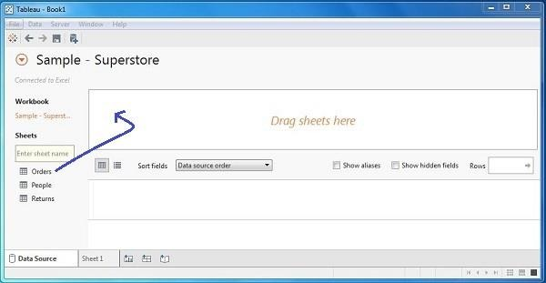

Choose the Dimensions and Measures

Next, choose the data to be analyzed by deciding on the dimensions and measures. Dimensions are the descriptive data while measures are numeric data. When put together, they help visualize the performance of the dimensional data with respect to the data which are measures. Choose Category and Region as the dimensions and Sales as the measure. Drag and drop them as shown in the following screenshot. The result shows the total sales in each category for each region.
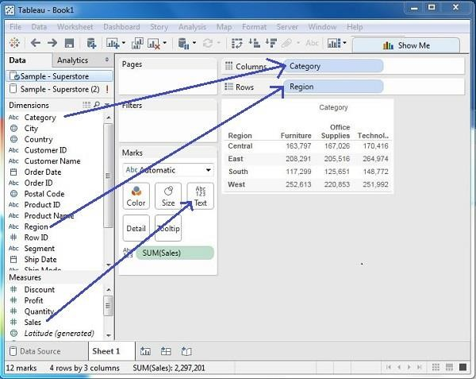

Apply Visualization Technique

In the previous step, you can see that the data is available only as numbers. You have to read and calculate each of the values to judge the performance. However, you can see them as graphs or charts with different colors to make a quicker judgment.

We drag and drop the sum (sales) column from the Marks tab to the Columns shelf. The table showing the numeric values of sales now turns into a bar chart automatically.

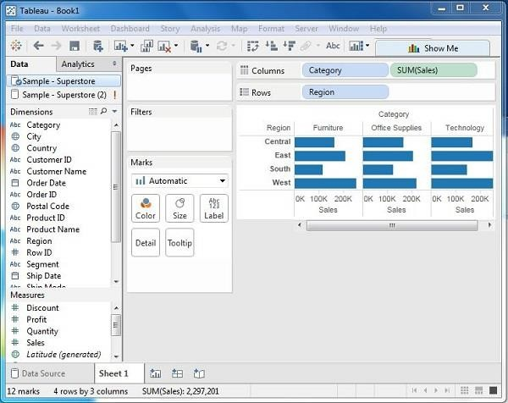

You can apply a technique of adding another dimension to the existing data. This will add more colors to the existing bar chart as shown in the following screenshot.
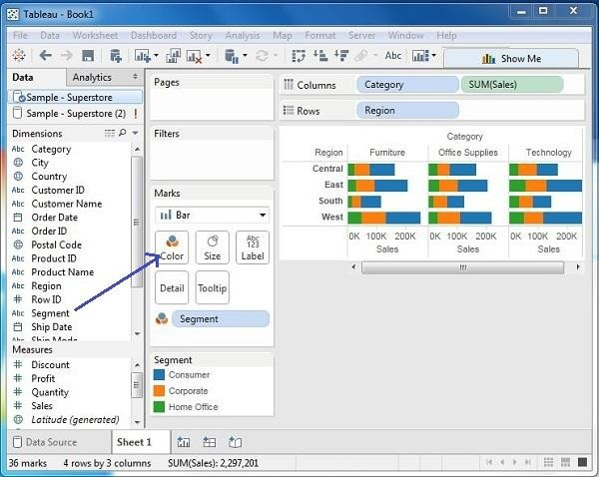

Conclusion: Thus we have learnt how to Visualize the data in different types (1 1D (Linear) Data visualization,2D (Planar) Data Visualization, 3D (Volumetric) Data Visualization, Temporal Data Visualization, Multidimensional Data Visualization, Tree/ Hierarchical Data visualization, Network Data visualization) by using Tableau Software.

Group C: Model Implementation

- Create a review scrapper for any ecommerce website to fetch real time comments, reviews, ratings, comment tags, customer name using Python.

- Develop a mini project in a group using different predictive models techniques to solve any real life problem. (Refer link dataset- https://www.kaggle.com/tanmoyie/us-graduate-schools- admissionparameters)

Reference Books:
- Big Data, Black Book, DT Editorialservices, 2015 edition.
- Data Analytics with Hadoop, Jenny Kim, Benjamin Bengfort, OReilly Media, Inc.
- Python for Data Analysis by Wes McKinney published by O' Reilly media, ISBN : 978-1-449- 31979-3.
- Python Data Science Handbook by Jake VanderPlas https://tanthiamhuat.files.wordpress.com/2018/04/pythondatasciencehandbook.pdf
- Alex Holmes, Hadoop in practice, Dreamtech press.
- Online References for data set http://archive.ics.uci.edu/ml/ https://www.kaggle.com/tanmoyie/us- graduate-schools-admission-parameters https://www.kaggle.com

